Day5
Programs1:-To find sum of 3numbers

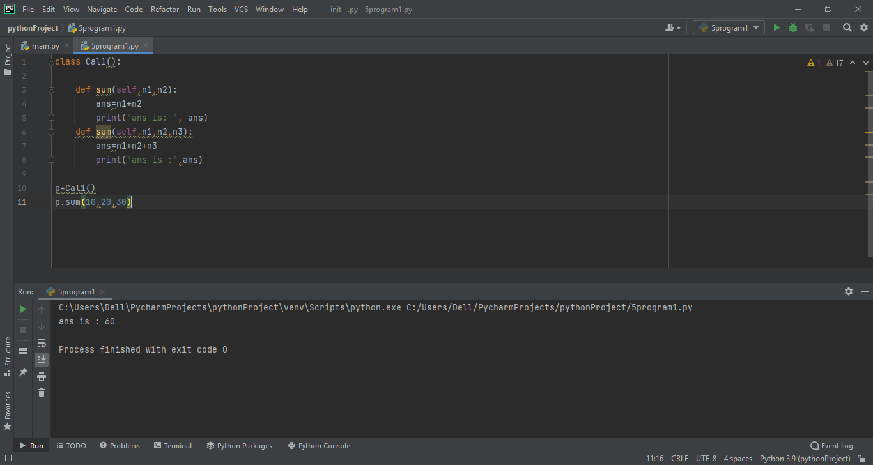
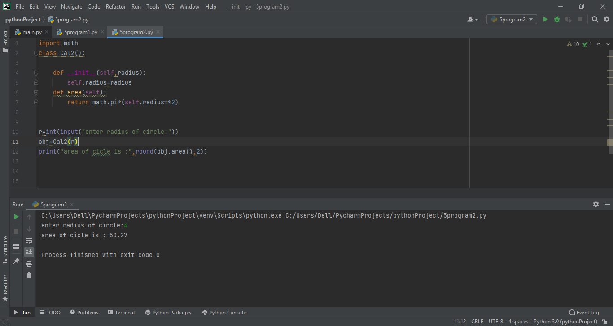
Program2:-
Find area of circle
Program3:- to find simple interest of any amount

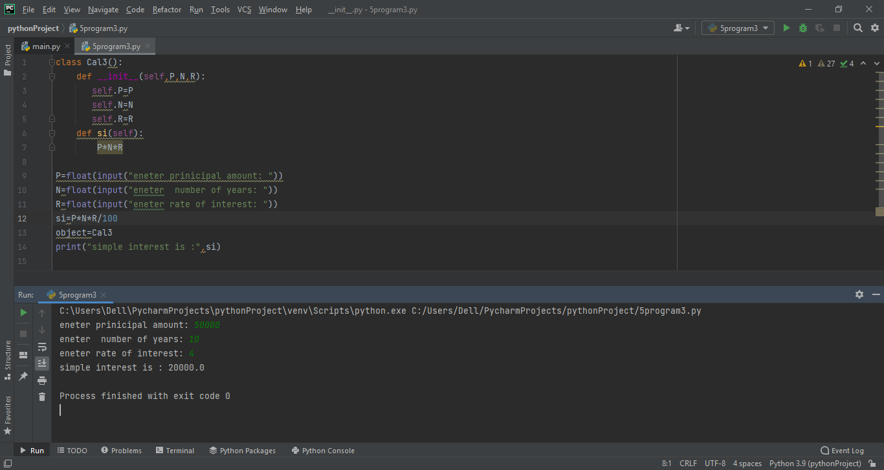
Program:-4
Square of a number

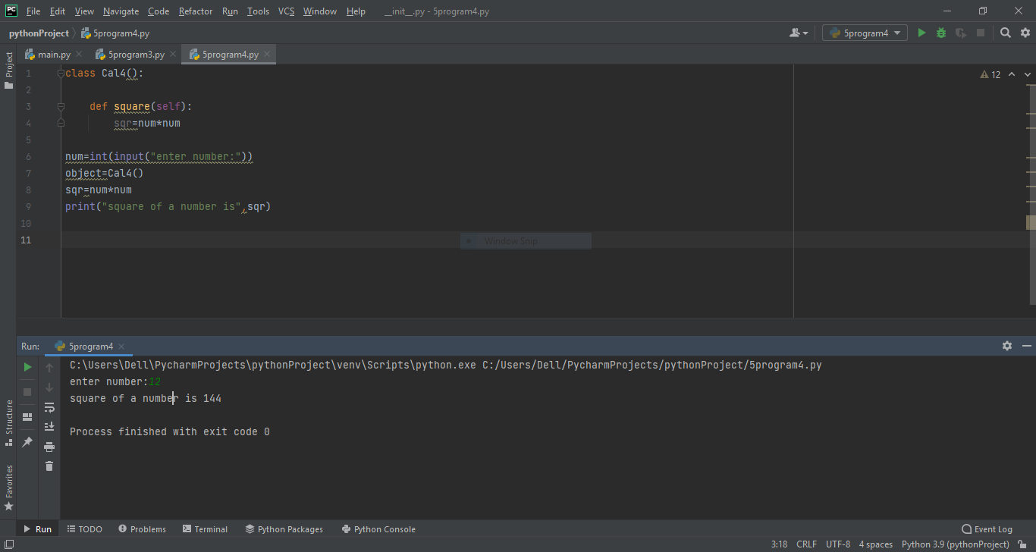
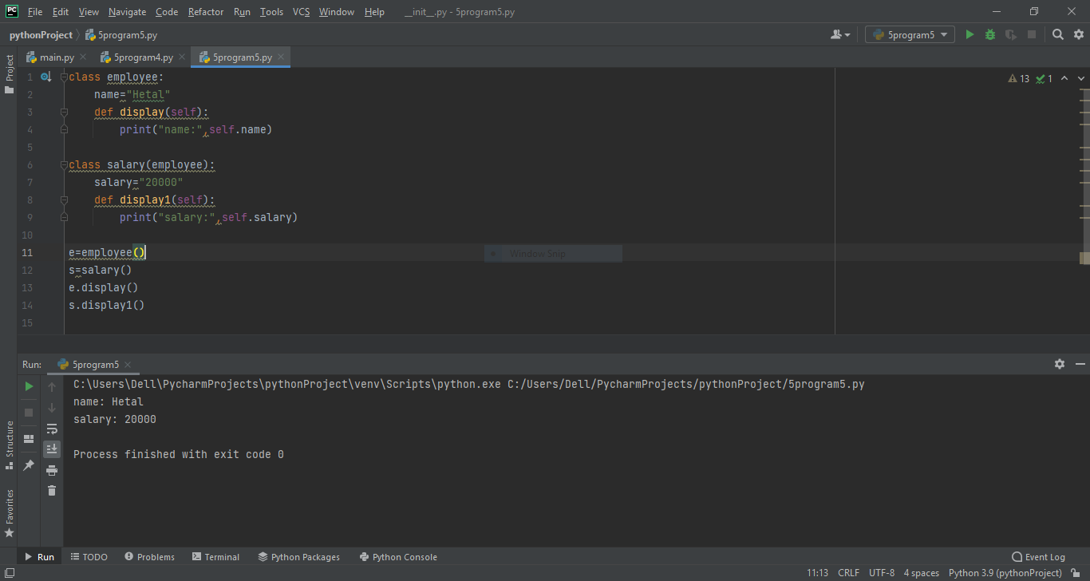
Program:-5
Show employee and salary by using display method
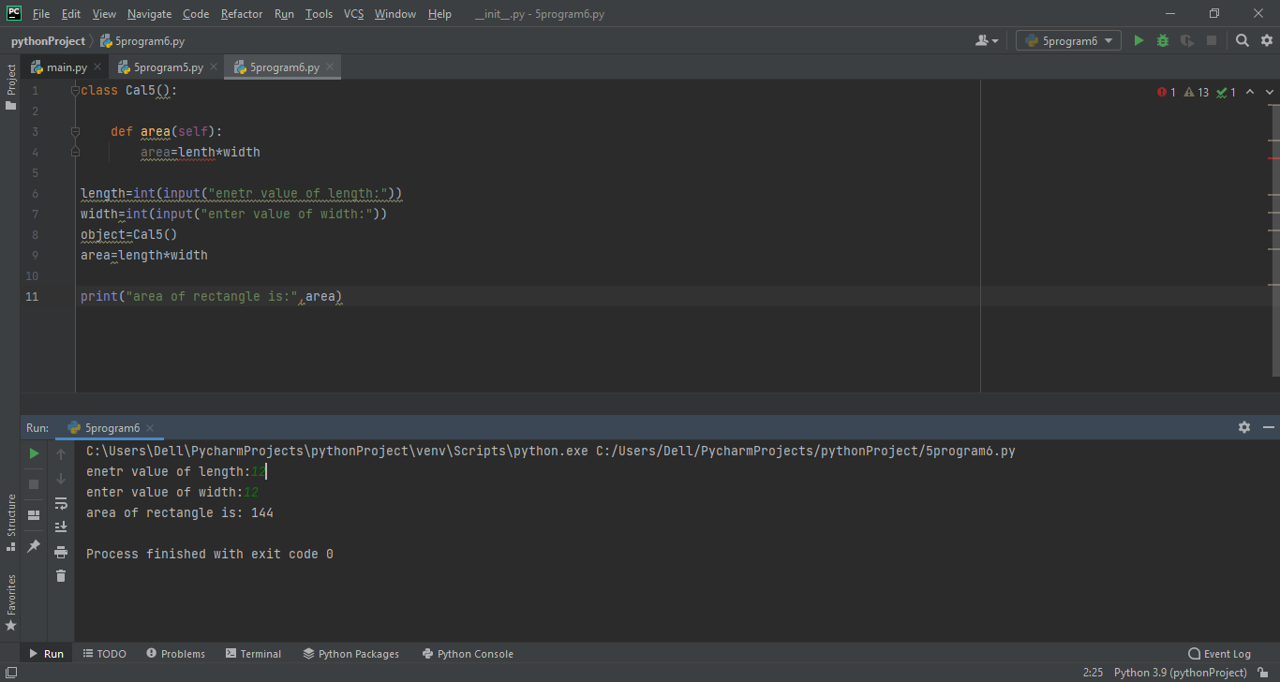
Program6:-
Find area of rectangle
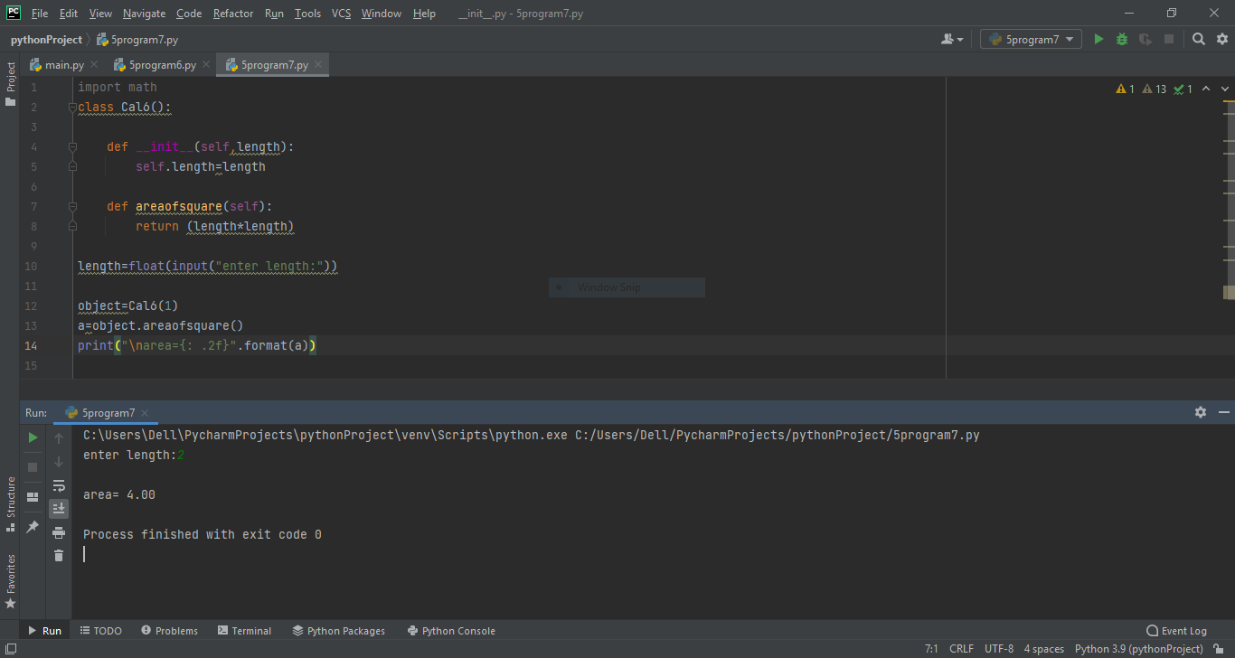
Program7:-
Find area of square

Program8:-
Show publisher and books details by using display method
class Publisher:
name = "abc Publication"

def display(self):
print("Name: ", self.name)

class Book(Publisher):
pageNo = "1140"
def display1(self):
print("pageNo: ", self.pageNo)

class Tape(Publisher):
time = 50

def display2(self):
print("Time: ", self.time)

b = Book()
t = Tape()
b.display()
b.display1()
t.display2()

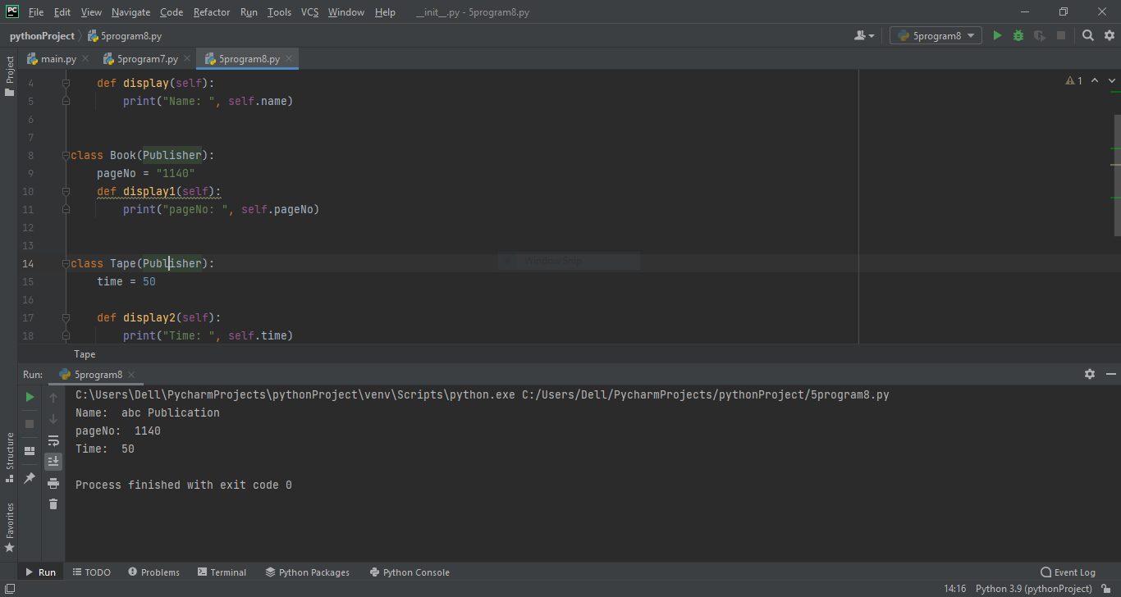

Program:-9
Create a class called scheme with scheme_id,
scheme_name,outgoing_rate, and message_charge. Derive customer
class form scheme and include cust_id, name and mobile_no
data.Define necessary functions to read and display data.

class Scheme:
scheme_id = 1
scheme_name = "airtel"
outgoing_rate = 2
message_charge = 1
def display(self):
print("scheme_id: ",self.scheme_id)
print("scheme_name: ",self.scheme_name)
print("outgoing_rate: ",self.outgoing_rate)
print("message_charge: ",self.message_charge)

class Customer(Scheme):
cust_id = 1
name = "Hetal"
mobile_no = 4546184842
def display1(self):
print("cust_id: ",self.cust_id)
print("name: ",self.name)
print("mobile_no: ",self.mobile_no)

cust = Customer()
cust.display()
cust.display1()

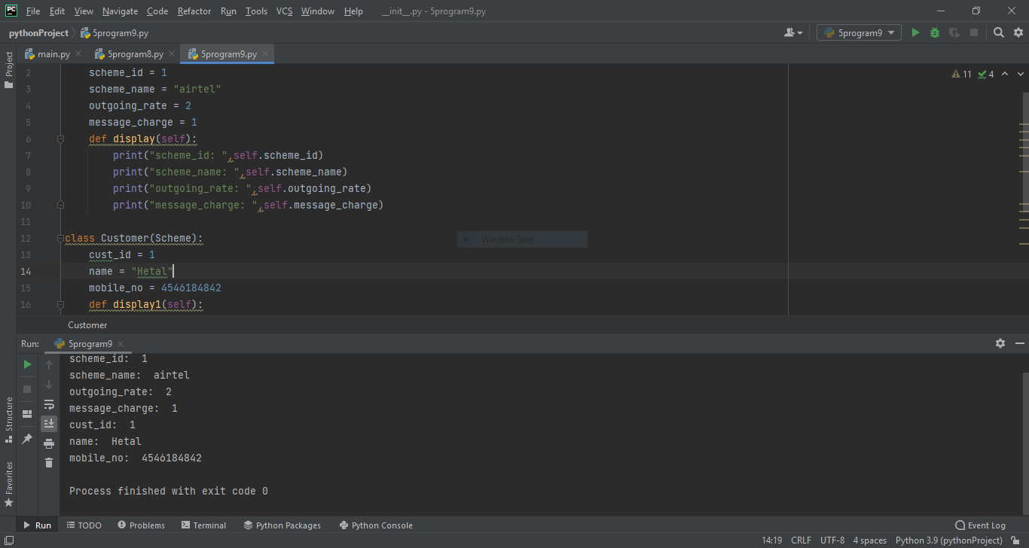
Program 10:-

Create a arith class. The class should have a parameterized constructor
and methods to add, subtract and multiply two numbers and to return
the answers.
class arith():
def __init__(self, a, b):
self.a = a
self.b = b

def add(self):
return self.a + self.b

def mul(self):
return self.a * self.b

def div(self):
return self.a / self.b

def sub(self):
return self.a - self.b

a = int(input("Enter first number: "))
b = int(input("Enter second number: "))
obj = arith(a, b)
choice = 1
while choice != 0:
print("0. Exit")
print("1. Add")
print("2. Subtraction")
print("3. Multiplication")
print("4. Division")
choice = int(input("Enter choice: "))
if choice == 1:
print("Result: ", obj.add())
elif choice == 2:
print("Result: ", obj.sub())
elif choice == 3:
print("Result: ", obj.mul())
elif choice == 4:
print("Result: ", round(obj.div(), 2))
elif choice == 0:
print("Exiting!")
else:
print("Invalid choice!!")

print()
